Barony of Endewearde Meeting Agenda
7:00 PM, 29 March 2023
TOPIC | RESPONSIBILITY | TIME  (in  minutes) | STATUS, ACTION, DISCUSSION
Call Meeting to Order, Working Agreements for this Meeting & Modified Robert’s Rules, Call for Additional Agenda Items, Time Keeper | Maistir Seamus | 5
Baroness & Baron address | Baroness Melisaunde de Vianne & Baron Gwillim Kynith | 5
Officer Reports |  | 15
Recent Events:  Feast of Saint Sylvester  Tourney of Love |  | 10
Future Events (various):  Jehan’s.  Demo at the Fort. |  | 15
Annual Budget Meeting report | Exchequer | 10
Report on Baronial day shade/pavilion project | Exchequer & Baron. | 5
Determine next meeting date/time/location | Maistir Seamus | 5
Adjourn

Working Agreements | OUR Rules of Order
- Start and End on time  Share Air Time  - One conversation at a time, please  Stay open to new ideas  - Participate fully when comfortable  Disagree with respect | - Make a motion stating, "I move that..."  - Motion must be seconded.  - Topic is open for discussion.  - Someone may move to amend the motion, which must be seconded.  - When discussion ends, the original and final amended motions are re-read. If the amended version meets the goals and intentions of the original motion, we proceed with the vote. If not, continue discussion and amendments.  - If at any time discussion gets off topic, we may declare a point of order to bring discussion back. If a discussion becomes too long, it may be moved to table the topic for a later meeting.  - Votes can be yay, nay, or abstain.
Term | Office | Current Officer
Term  Schedule 1  (2019-2022) | Chamberlain | Drottin Hrafn Isauga
 | Herald | Mistress Brita Mairi Svensdottir
 | Minister of Lists | Lady Mór Cille Caindigh
 | Local Fencing Marshal | Lord Radbod of Endewearde
Term  Schedule 2  (2020-2023) | Web Minister | Mistress Aneleda Falconbridge
 | Chancellor Minor | THL Thomas de Marr
 | Knights Marshal (KM) | Lord Thorbjorn Thorfinnsen.
 | Minister of Arts and Sciences (MoAS) | Lady Ysenda Cleland
 | Local Youth Fighting Marshal | THL Thomas de Marr
 | Local Youth Fencing Marshal | VACANT
Term  Schedule 3  (2021-2024) | Chronicler | Marjorie Kinlock
 | Chatelaine | THL Eoin an Doire
 | Exchequer | Lady Admiranda Howard
 | Local Archery Captain | Lord Njall Randvesson
 | Local Thrown Weapons Marshal | VACANT
 | Seneschal (begins Jan. 2021) | Maistir Seamus na Coille Aosada
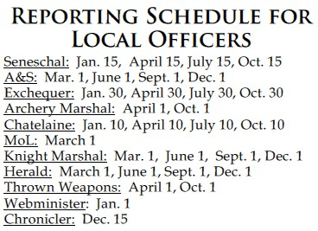
Reprinted from the Pikestaff.

THE SCA PROHIBITS HARASSMENT AND BULLYING OF ALL INDIVIDUALS AND GROUPS.
Participants engaging in this behavior are subject to appropriate sanctions.
If you are subjected to harassment, bullying or retaliation, or if you become aware of anyone being harassed or bullied,
contact a seneschal, President of the SCA, or your Kingdom’s Board Ombudsman.

